**Lab # 03**

**OBJECTIVE: To learn RMI basics: Generate the stubs and skeletons and run client and server**

**Task 1: Create RMI program in which server performs basic arithmetic operations.**

**Interface class**

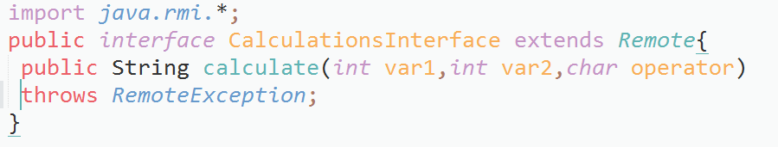

**Calculation class**

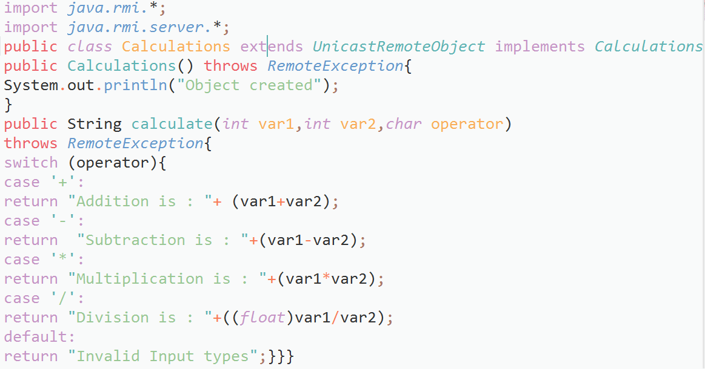

**Server Class**

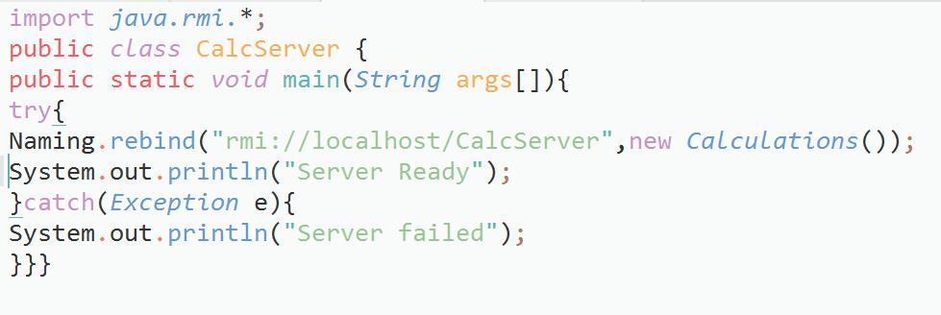

**Client Class:**

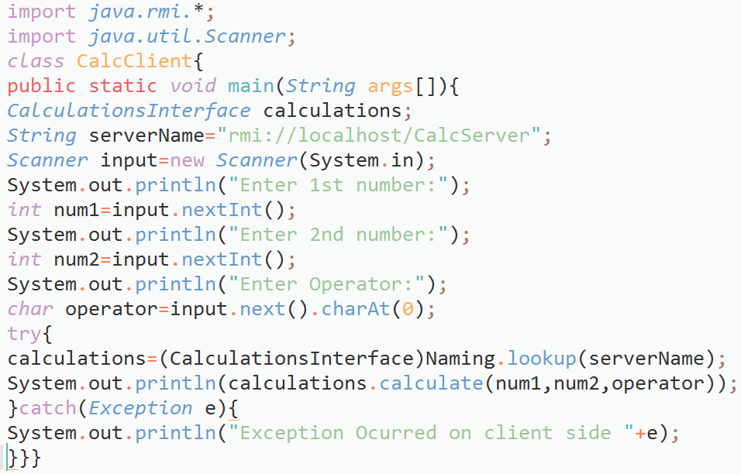

**Output:**

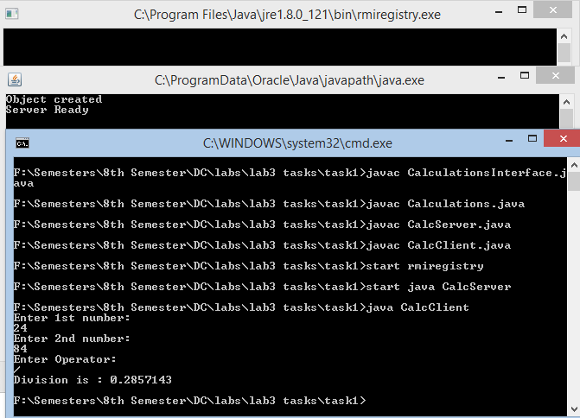

**Task 2: Create RMI program in which server sorts the numbers in ascending order.**

**Interface class:**

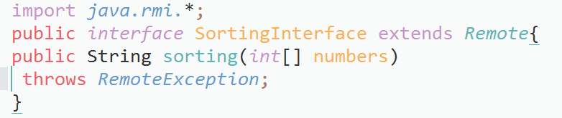

**Sorting class:**

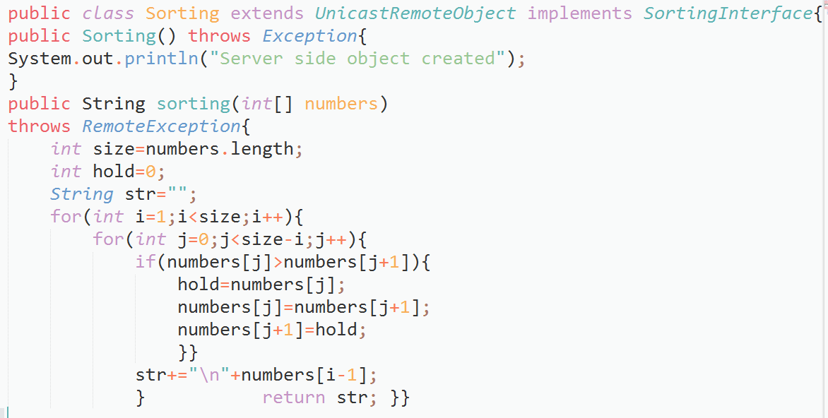

**Server class:**

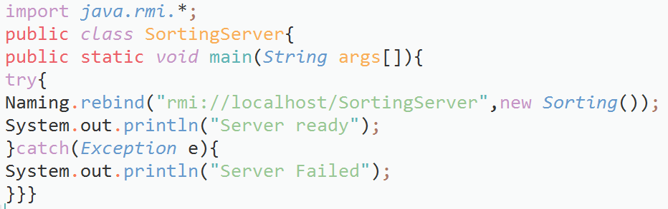

**Client Class:**

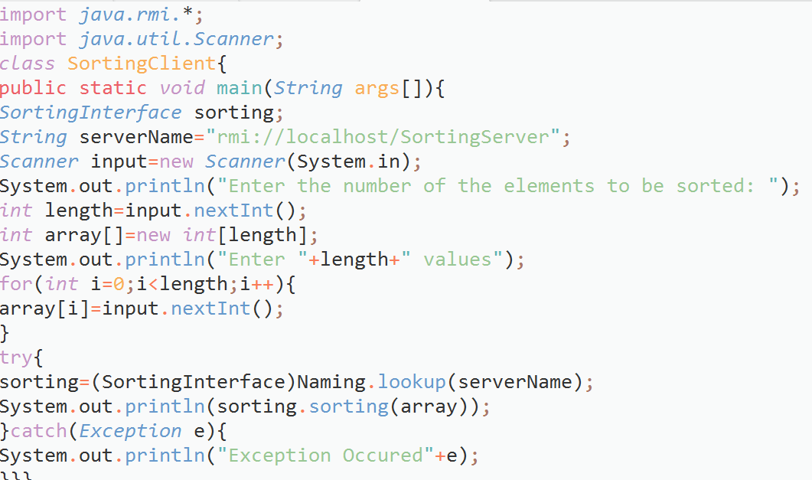

**Output:**

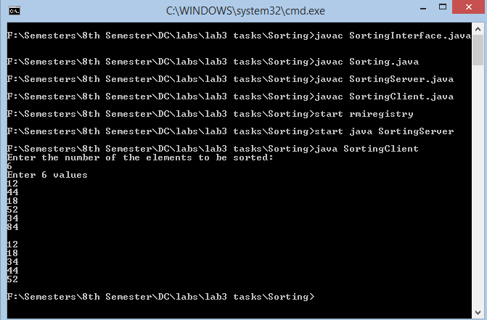

**Task 3: Write an RMI program to implement the Map/Reduce concept of Hadoop on the server program. In other words the client program asks user to provide multiple sentences and send to server, server sends back the word counts.**

**Interface class:**

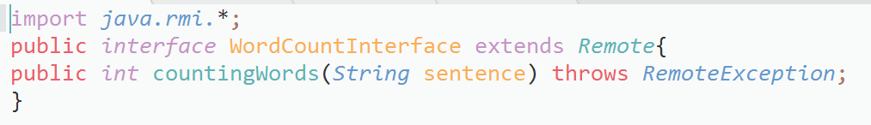

**Wordcount class:**

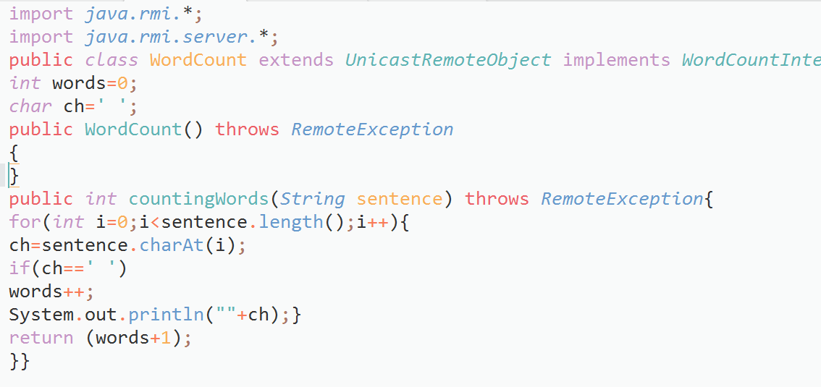

**Server class:**

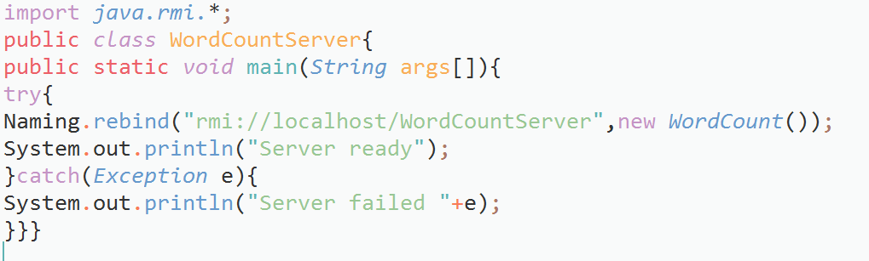

**Client class:**

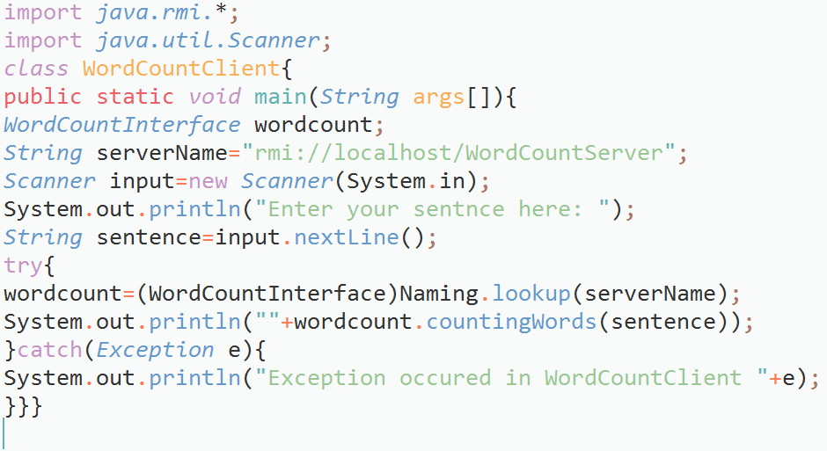

**Output:**

